**PRD TEMPLATE**

**Chris Manfredi**

**ASL**

**Project/App Title**

*Around The Bases*

**Project/App Summary**

*This application is a baseball application. When the user enters the interface they will be at a launch screen which will require them to login or register for an account. After logging into an account the user will have a few options to click on. The user will be able to see MLB scores from the previous day, see a schedule of upcoming games of all the teams in the MLB. They application will also have rosters of all the teams in in both AL and NL, The standings for both AL and NL, and the application will include the MLB league leaders.*

**Weekly Schedule**

**Sunday - Monday:** *Research and planning*

**Tuesday - Thursday:** *Development*

**Friday - Saturday:** *Testing and debugging*

**Time Of Completion**

**Week 1**

*For week 1 I plan on developing the PDR for the project, wireframes, and the framework selection research activity.*

**Week 2**

*For week 2 I plan on developing 2 basic functions for the application. Which consists of the Scoring for the MLB Games, and Schedules for the MLB Games.*

**Week 3**

*For week 3 I plan on developing 2 additional features for the application. Which consists of the American League and National League Rosters for the all the MLB teams.*

**Week 4**

*For week 4 I plan on developing 2 additional features for the application. Which consists of adding the standings of both the American League and National League, also I plan on adding the League Leaders functionality to the application.*

**Diagrams**

**Launch Page**

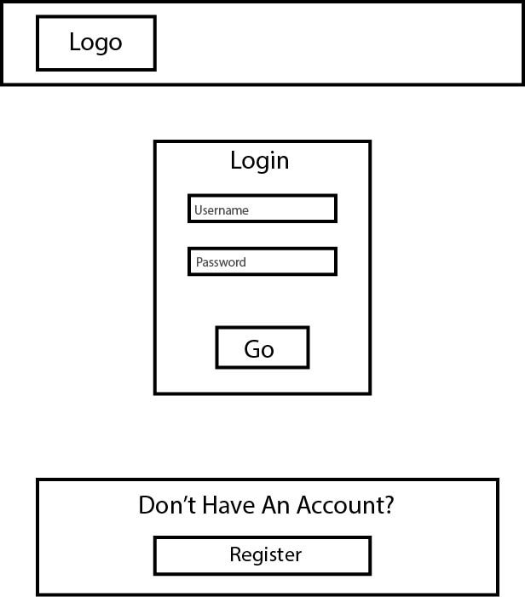

**Registration Page**

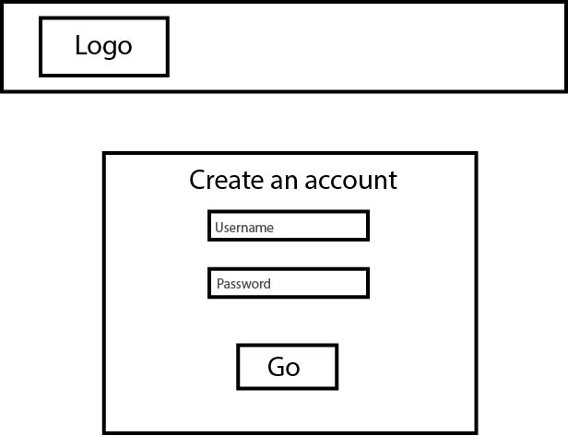

**Home Page**

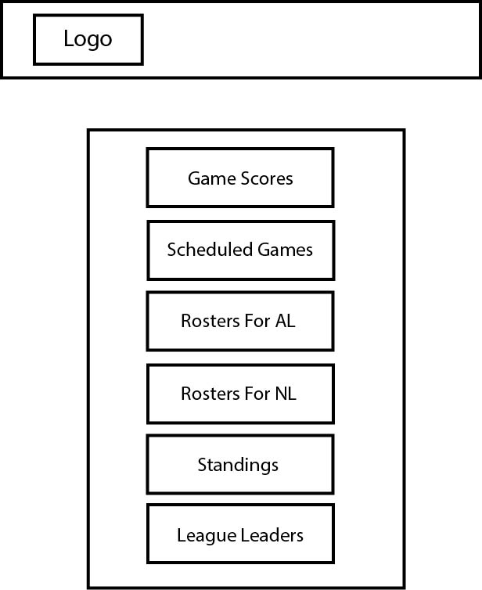

**Game Scores Page**

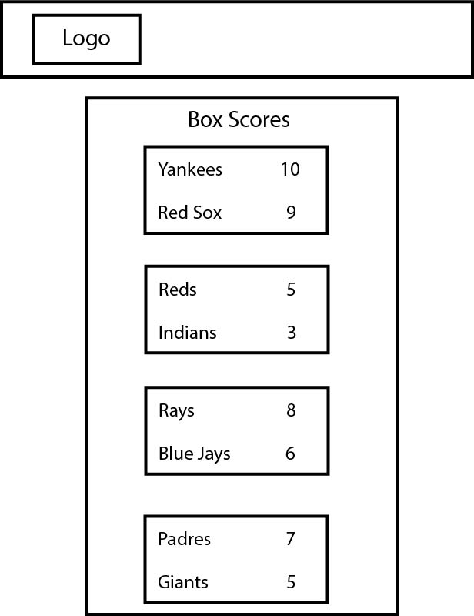

**MLB Schedule Page**

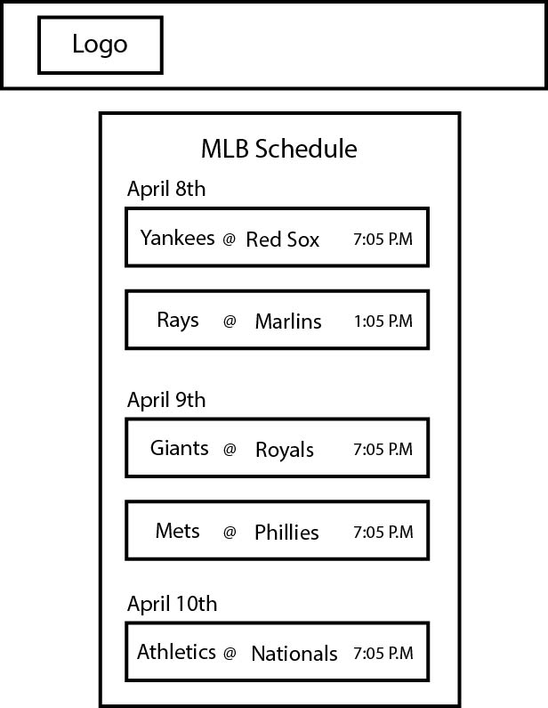

**MLB Standings Page**

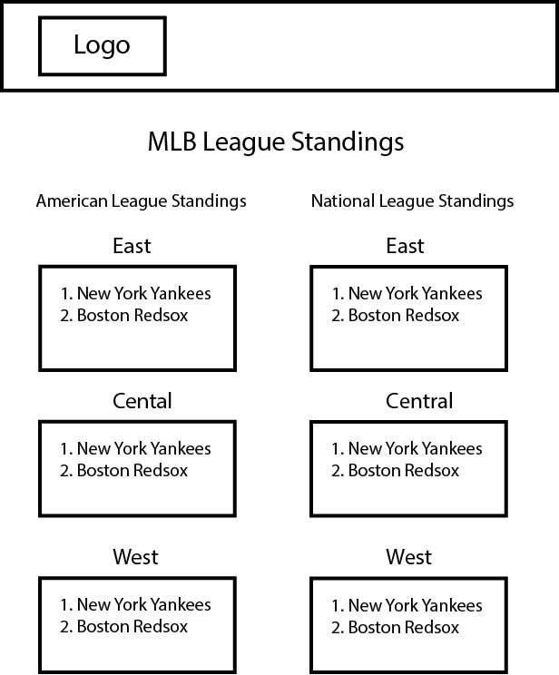

**MLB League Leaders Page**

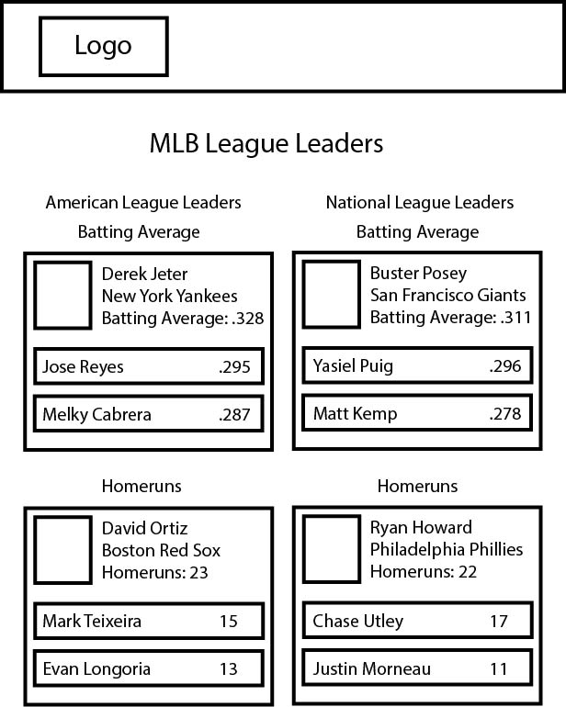

**American League Rosters Page**

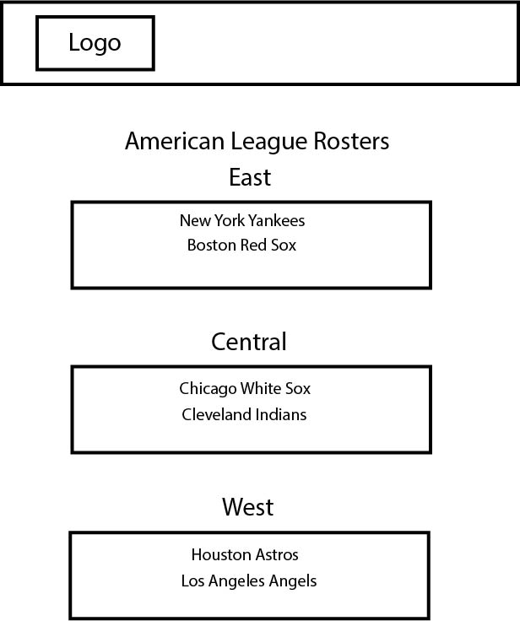

**National League Rosters Page**

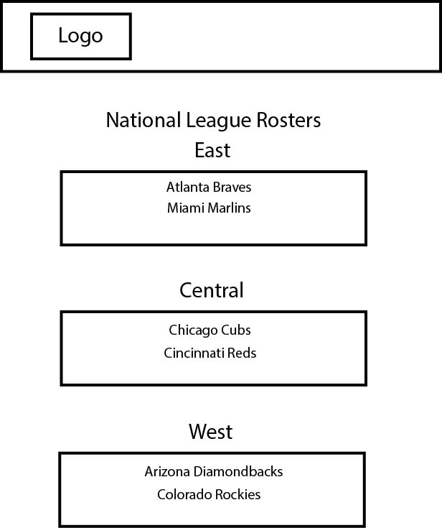

**Language and framework**

**Language**

*PHP*

**Framework**

*Laravel*

**Flow Chart**

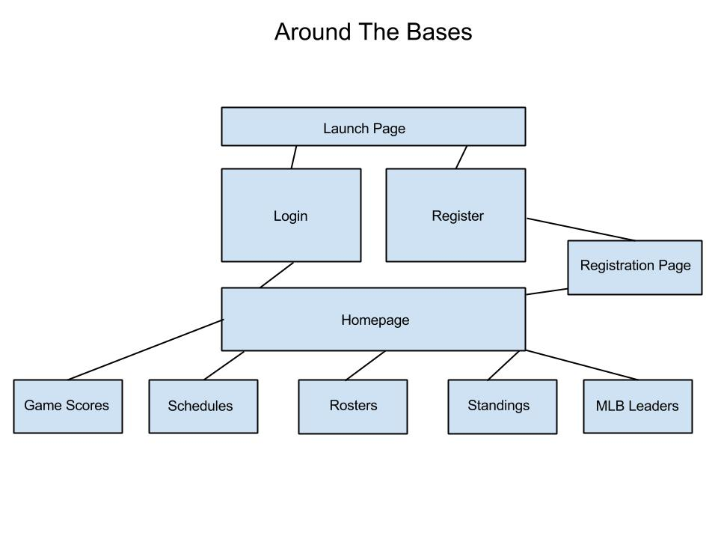

**Version one**

When I have successfully completed the first version of Around The Bases I will have added all the basic functionality to the application. Adding the Scores, Schedules, Rosters, Standings, and League Leaders.

**Version two**

If I had more time to work on this application I would go more in depth with the game stats and what happened during the game. I would also incorporate starting lineups for each game and starting pitchers